Edge Delivery Services: Document-Based Authoring Lab Session
  - Hands-On Experience with Lightning-Fast Publishing

Lab Session Structure
- Setup Edge Delivery project (Developers)
- Publish / Preview content – Sidekick (Content Authors & Developers)
- Utilizing Share point for authoring content.( Content Authors & Developers)
- Create new page and preview/publish (Content Authors & Developers)
- Create new block (Developers)

Prerequisite
- Github account (for Devs)
- Adobe Share point access (Users to be added)
- Understand basics of HTML, CSS & JavaScript
- Node/npm installed for local development (only for Devs)

Participant Takeaways
- First-hand experience with the content lifecycle—preview and publish—without leaving the document editor.
- Understanding how Edge Delivery Services and document-based authoring combine to drive digital experience innovation.
- How to create a page
- How to author content (add sections, blocks (components) and how to apply different styles

Steps to setup Edge Delivery Services project|
- Create new repo using use this template option
Repo - https://github.com/adobe/aem-boilerplate
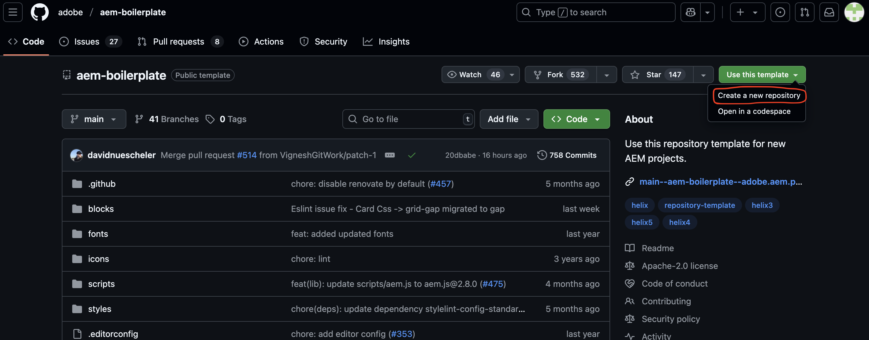

- Click the Use this template button and select Create a new repository, and select the user org that owns the repository
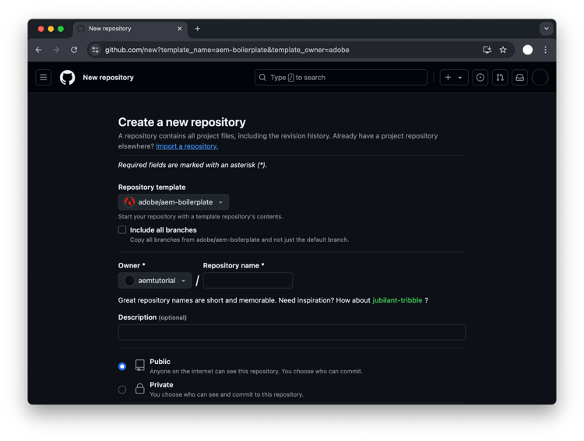
- Install the AEM Code Sync GitHub App on your repository by visiting this link: https://github.com/apps/aem-code-sync/installations/new
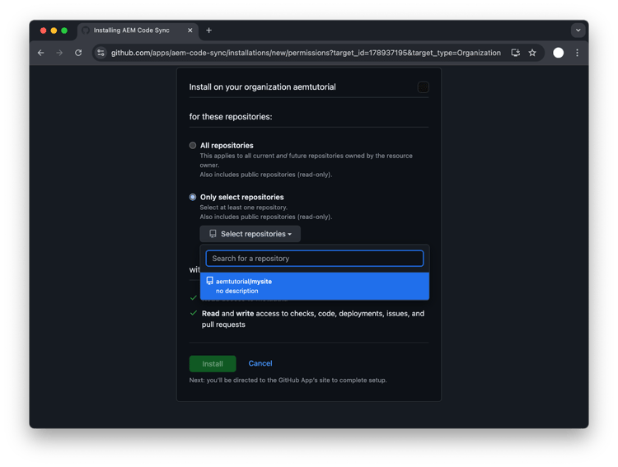

- Copy the started content to your Share point
- Share docs with helix@adobe.com
- Update share point path in fstab.yaml configuration file
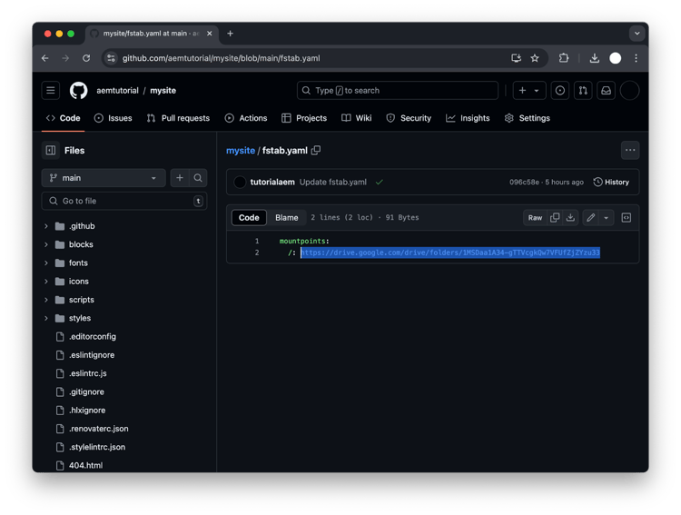

AEM Sidekick to preview or Publish

- Install the Sidekick Chrome extension using
https://chromewebstore.google.com/detail/aem-sidekick/igkmdomcgoebiipaifhmpfjhbjccggml

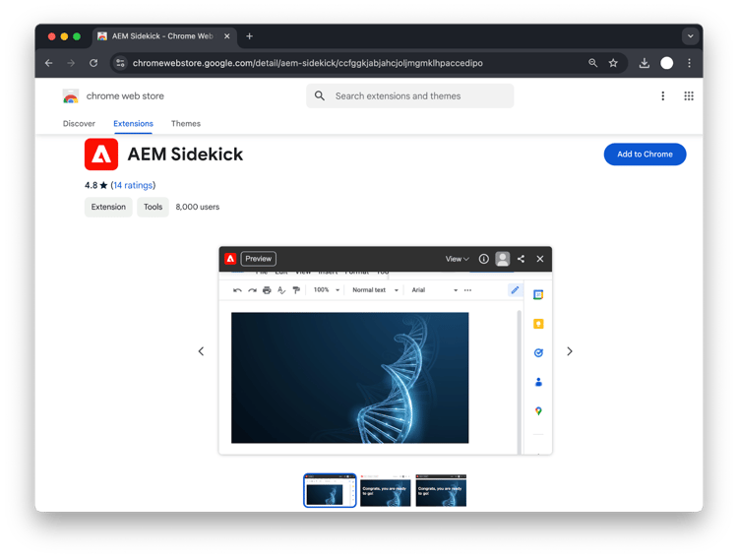

- Pin the extension to make it easier to find it.

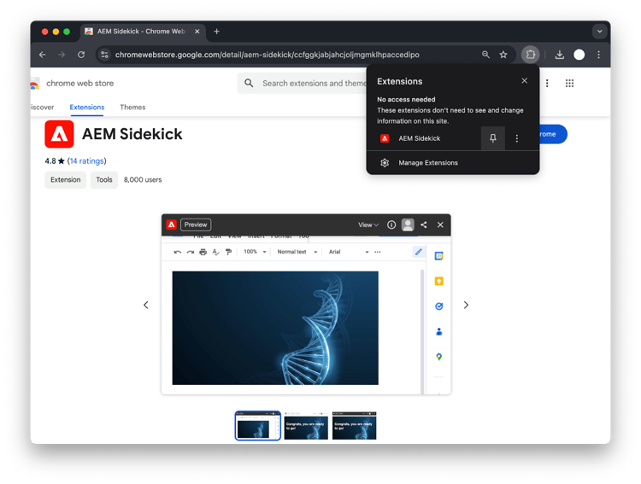

- To set up the Chrome extension, go to your previously shared Share point folder and click the extension icon in the browser toolbar and select Add this project
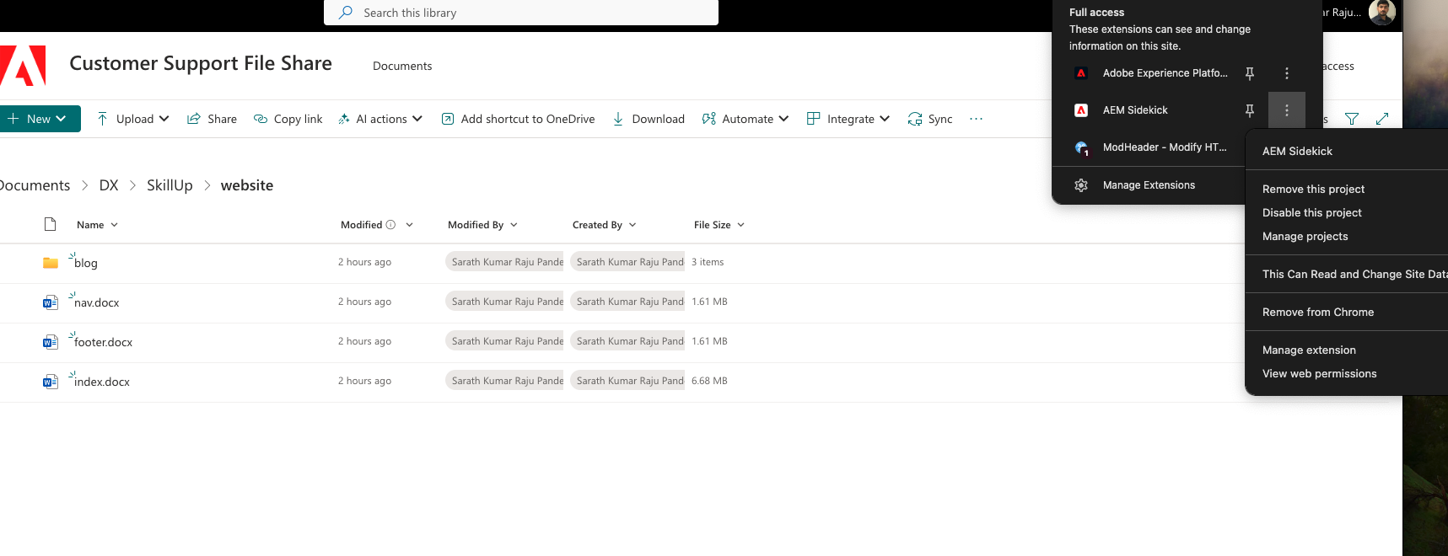
- you are now ready to preview and publish your content from the Share point.

Exercise :
Create new Page
- Go to share point folder and navigate to blog folder.
- Create a new folder with your name (example sample)
- Now under blog folder select Exercise.docx file and click on 3 dots and use copyto option and select the folder you have created (example sample).
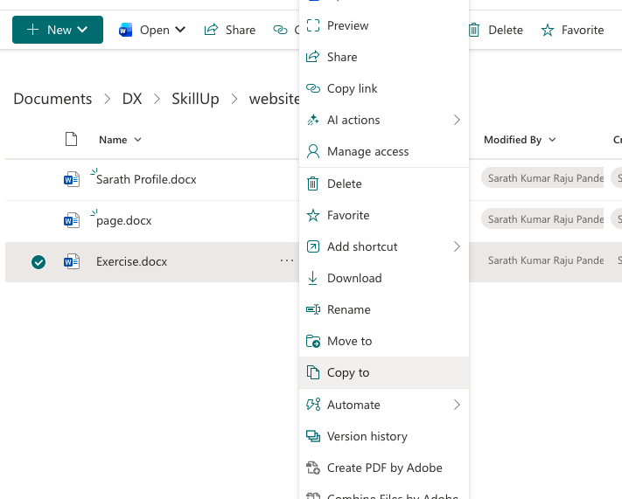
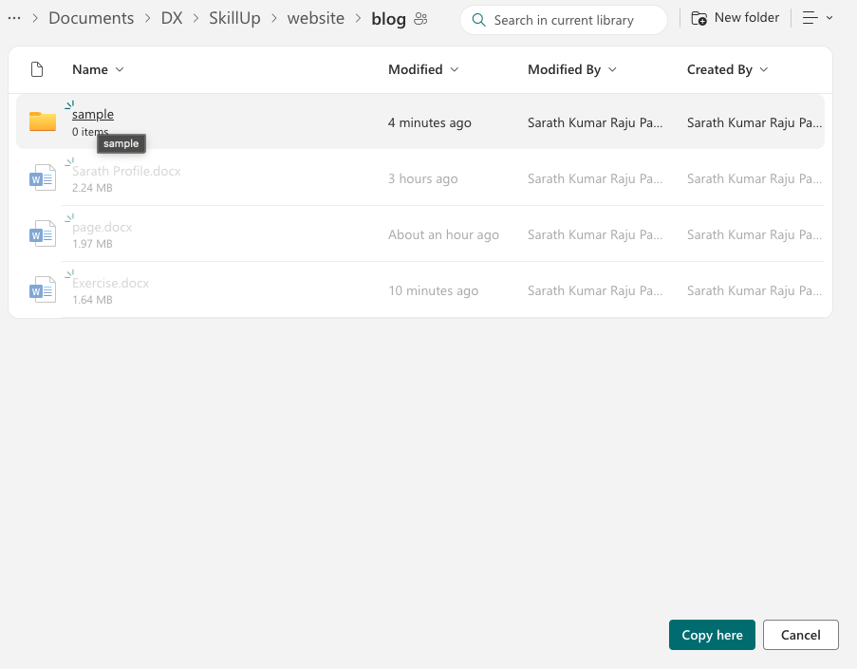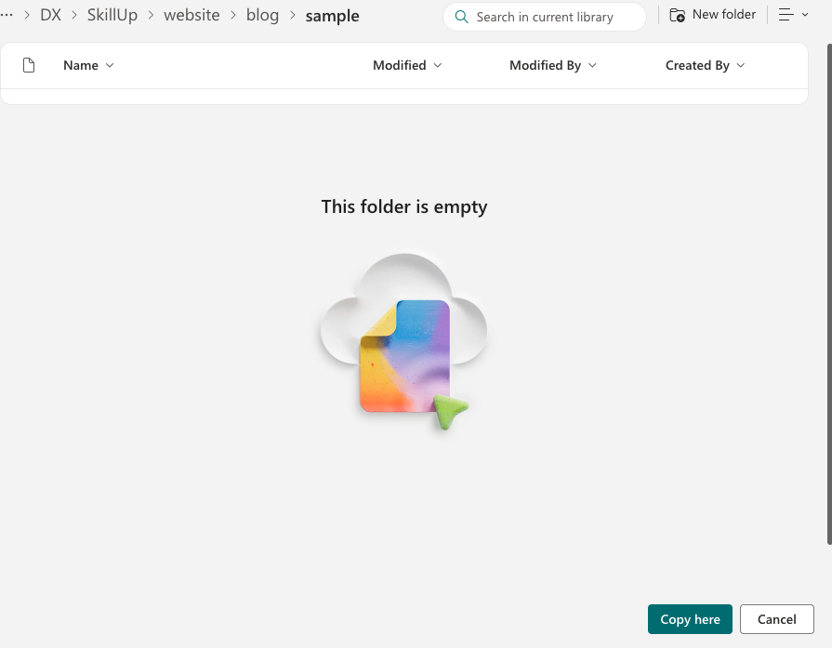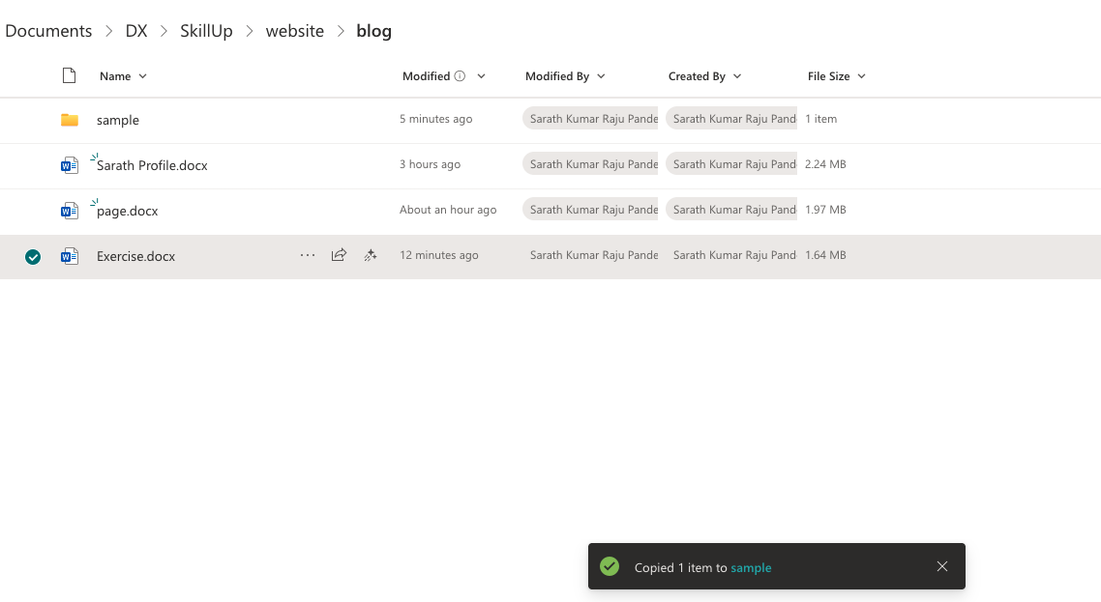

- Navigate to the folder you created and open exercise.docx file
- Once the document is opened you can see sidekick shows only preview

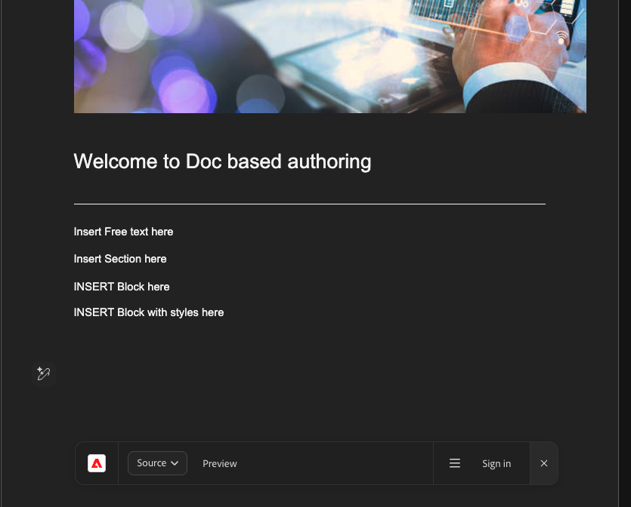
- You can start editing the page

- How to insert a section (add 3 hyphens and enter) you should be able to see a horizontal line
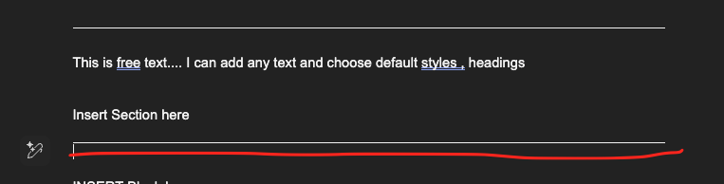
- How to insert a Block (we will use cards & profile blocks for exercise)
Blocks are authored via tables. Insert a table 2*3
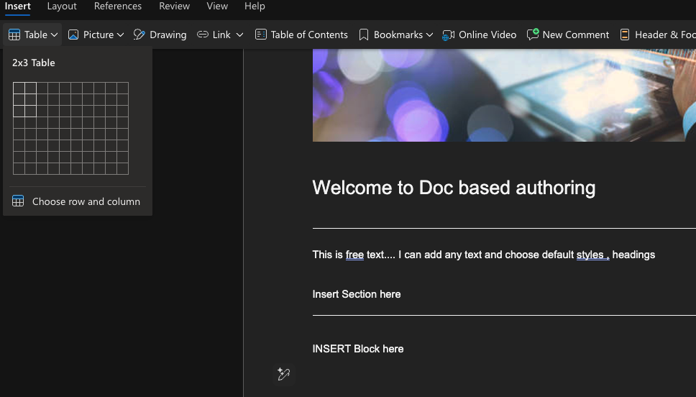
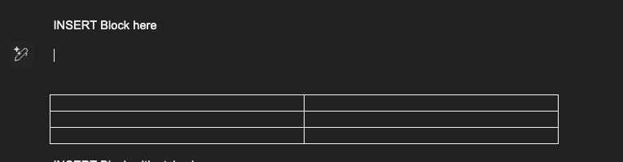
Using Cards Block :
Merge the first row and add a text called cards(name of the block)
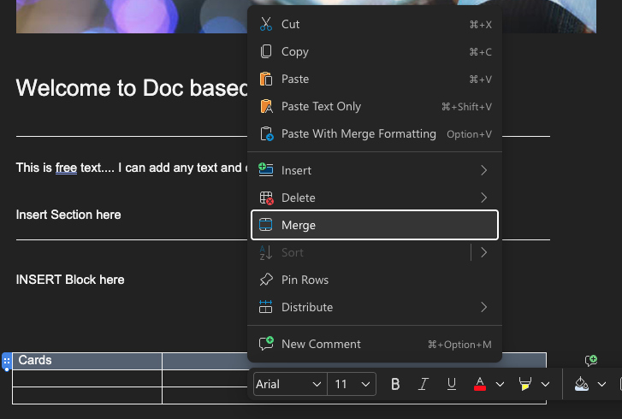
From Second row -> left insert image and right side you can add text.
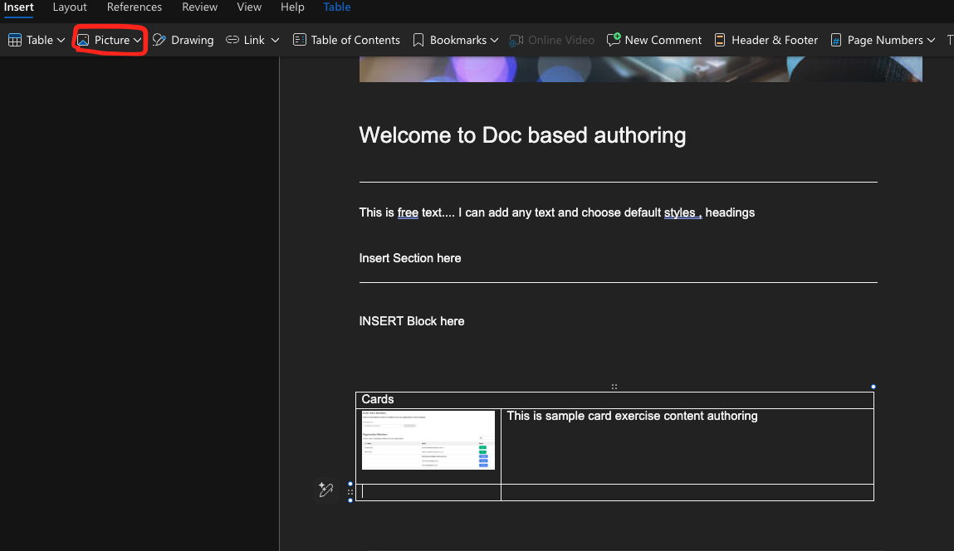
How to use specific style for a block. (Just add style name developer created inside () after the block name)
Using Profile Block – for exercise we have created style ‘highlighted’

Insert 2*2 table and insert image like below
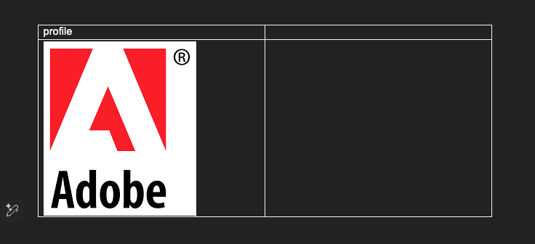
To use specific style here we are using highlighted
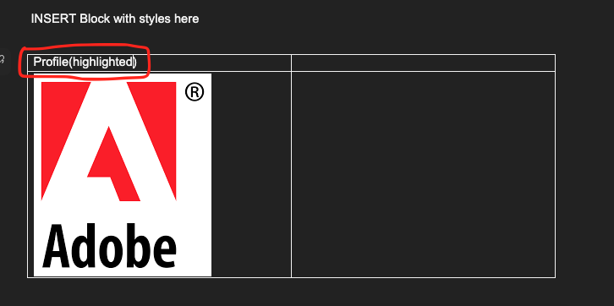

- Author the block component (cards)
- Preview the content using sidekick and review the content
Once you click preview It will open the preview page or You should be able to preview via - https://main--skillup--sarathraju.aem.page/blog/sample/exercise
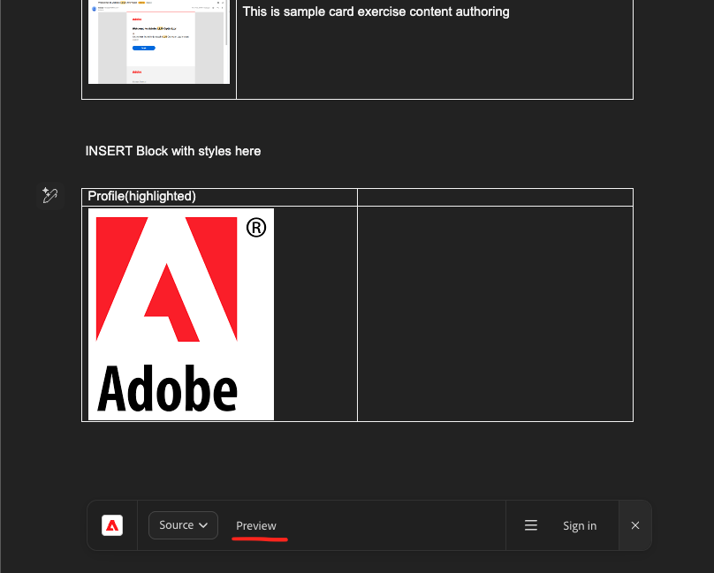
- Once the preview page opens you should be able to see Edit & Publish option in sidekick and you can publish using publish option
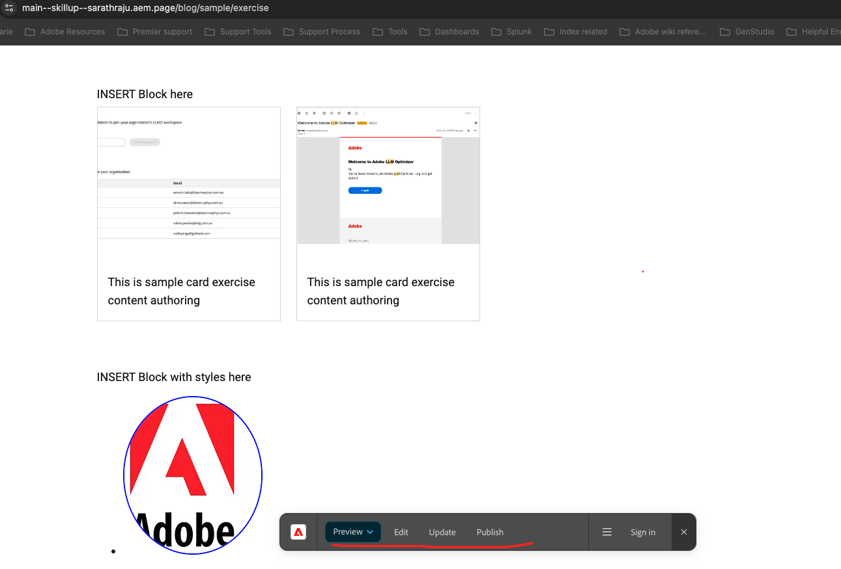

For Developers : To get started with development.

- Install the aem-cli plugin and check out the code repository

npm install -g @adobe/aem-cli
git clone https://github.com/<owner>/<repo>

- From there change into your project folder and start your local development environment using the following.
cd <repo>
aemup

- This opens http://localhost:3000/ and you are ready to make changes.
- Test your changes locally and then follow the standard process to push the code.

Lab Exercise :

Create a new block (profile).

Sample code reference: https://github.com/sarathraju/skillUp/tree/main/blocks/profile

Amend changes in your project and add new styles

